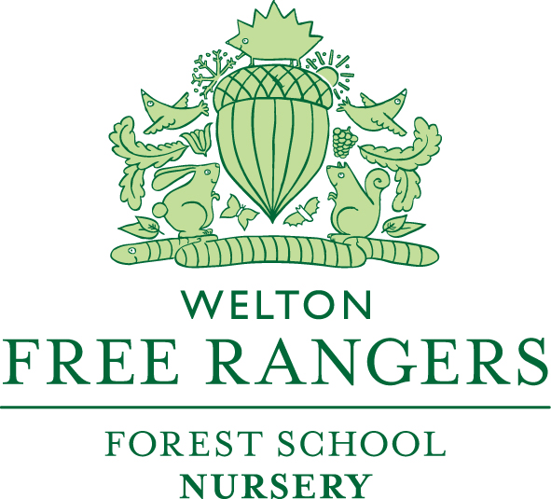

Safeguarding – The Prevent Duty March 2021

The Prevent Duty is the duty in the Counter-Terrorism and Security Act 2015; to prevent children, young person/s and adults being drawn into terrorism.
Free Rangers promotes a safe, secure and sound environment for children to discuss and display their feelings with a Key Person or familiar adult. This links to the Early Years Foundation Stage (EYFS) learning and development protocols; Personal, Social and Emotional Development and Understanding of the World.
Assessing children and families at risk to radicalisation and terrorism is of paramount importance to Free Rangers. It has been identified that there is no single way of identifying these cases. Free Rangers will follow the procedures as set out in our Free Rangers Safeguarding Policy. Children and families that are at risk of radicalisation and/or terrorism may display different signs of behaviour or seek to hide their views and feelings. Free Rangers will remain professional in their judgement when identifying these particular children and families. At no point in identifying the children will the Free Rangers staff be intrusive to the families’ life, views or religion, but will take appropriate action as required.
As set out in Free Rangers Safeguarding Policy the procedures and training remain the same. The Safeguarding Officer will attend relevant training as well as assess the level of cases and if the children or families are at risk or vulnerable to radicalisation or terrorism a referral to Channel will be made. Channel is a programme, which focuses on providing support at an early stage to people who are identified as being vulnerable to being drawn into terrorism. At this point all children and family’s engagement is voluntary.
Free Rangers link closely with the Local Authority and Local Safeguarding Children’s Board (LSCB’s) and emphasise Safeguarding practices throughout the care and education provided to our children.

Channel Contact Details: 02074939333 or info@counterextermism.org

