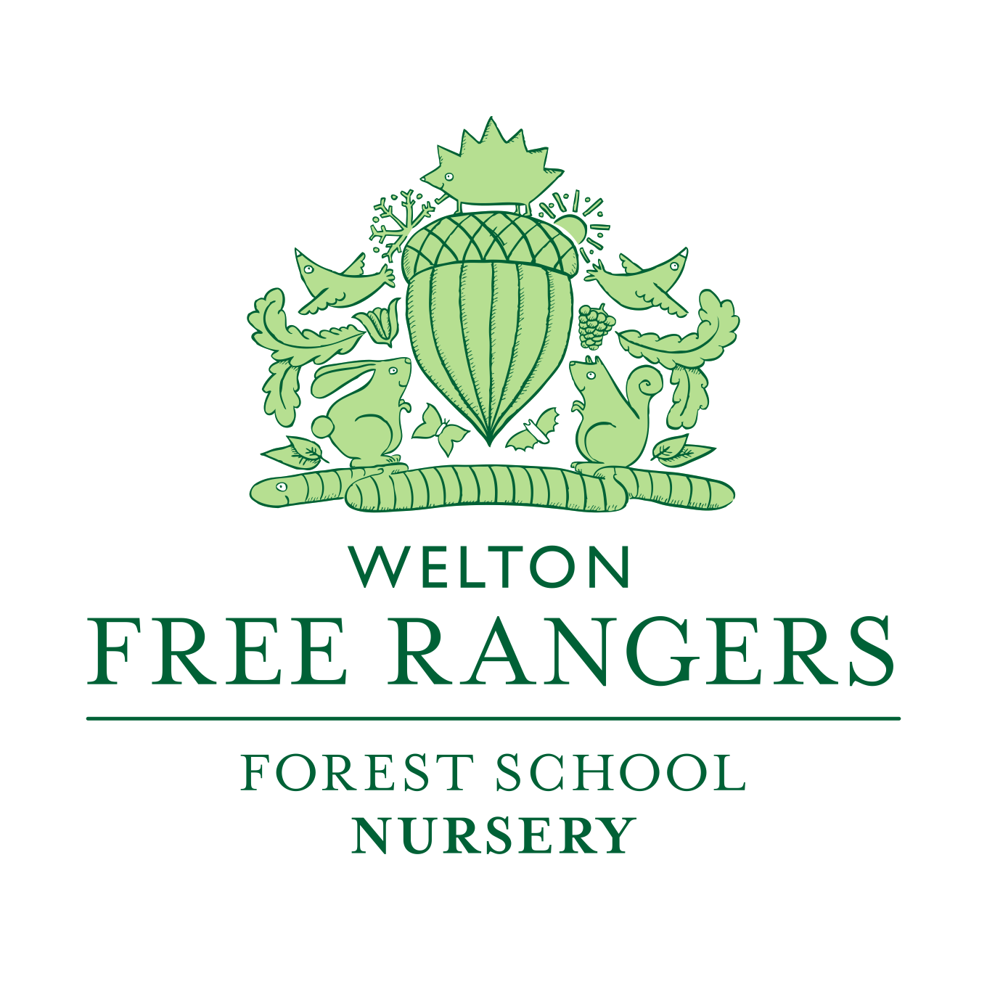
Learning Policy
Reviewed February 2021

This policy aims to make clear the process we use at Free Rangers to document your child’s learning in line with the Early Years Foundation Stage.
Our Mission Statement
At Free Rangers nursery ltd we recognise our individual responsibility to ensure our environment is one of kindness, enthusiasm and empathy and we are committed to ensuring each child’s happiness and wellbeing is nurtured on a daily basis.
We believe
- All children have a right to be happy
- Learning is fun
- The process of learning outweighs the product
- Learning must be relevant and meaningful
- Nature and the outdoors enhance learning
- Children learn through doing
- Children learn by engaging their senses
- Children need time to learn
- Nourishing food ensures better learning
Our ethos towards learning
At this stage it is important for us to share with you our beliefs with regards to the assessment and formalisation of our understanding of your child’s learning.
We wholeheartedly believe that our time is better spent engaging with your child. We believe meaningful interactions bring more impact to your child’s learning than spending hours typing up observations, which as soon as they have happened, are in the past and a mere snapshot of all the wonderful thoughts, interests, and interactions your child has whilst they are with us. We believe you have joined us at Free Rangers because you feel the same.
However, the paperwork is important too. The observation, assessment and planning loop we follow is crucial in helping us be the best we can be for your child. Early Years is not a race and it’s not something we feel your child needs to be pushed through. Free Rangers is not a mini school, we are a setting that believes an experiential and play based learning ethos is the best way for us to support your child and ensure a love of learning.
We plan depending on your child’s interests and linking this to the EYFS helps us to reflect and ensure that we are offering up a rich variety of learning opportunities that holistically support the development of your child and also helps us to liaise with you if your child might require additional support in an area.
Initially if you have any concerns regarding your child’s learning please speak to your child’s key person. If you have further questions, then the Room Leader or Manager is always available to discuss through matters.
If we wish to chat over any issues concerning your child’s learning with you, initially your child’s key person will discuss a time to meet with you and either the room leader or your child’s key person will be present, alongside Jessica Kendrick (Special Educational Needs Co-ordinator.)
It is important to stress that we will always be honest and open with regards to your child’s learning. We identify and believe that working together with families is very important and with that in mind our door is always open, and we will work tirelessly to ensure the best possible learning environment is in place for your child.
How do we document your child’s learning?
The Early Years Foundation Stage (EYFS) sets standards for the learning, development, and care of children from birth to 5 years old.
All schools and Ofsted registered early years providers must follow the EYFS, including childminders, preschools, nurseries and school reception classes.
We use an online learning journal, called Tapestry, on which to record and assess how your child is progressing in line with the standards of the Early Years Curriculum.
If we feel your child is not meeting their milestones or you have already recognised they might need extra support before you start with us, then please do look at our Local Offer, which can be found on our website; this details how we offer additional support for those children with an identified special educational need and/or disability.

How to access your child’s learning journal:
You will be able to access your child’s Tapestry account when you receive the email link. This link will be sent by Tanya in the first 4-6 weeks of your attendance. There is a time limit on the email and so you will be locked out of your account if you do not initially log in within five days of receipt of the email.
Username: your email address (the email address that your nursery invoice is sent to, please inform us if you wish two email address to receive the updates.)
Password: You will be prompted to create your own password.
Please email admissions@freerangers.org.uk with your child’s name and preferred email account details if you are having trouble logging in to your child’s online journal. Within the first four weeks of your child’s start with us, they will have observations uploaded to their secure, password protected Tapestry learning journal.
Your child’s key person will be in charge of uploading photos and written observations and also completing termly reports to show you where your child is achieving in line with the EYFS.
How often will I receive updates?
As practitioners we aim to achieve one detailed and focused observation regarding your child’s learning every fortnight. Alongside this we also aim to add an additional post that is more lighthearted but will still inform you about what your child has been up to whilst they have been with us, this is normally in the form of photographs. Essentially you can expect one post a week that reflects the individuality of your little person, this might be solely in written form, but we will endeavor to support our observations with images.
Please bear in mind that sometimes staffing absence and sickness might affect the timing of updates, alongside busy times throughout the term.
It is also really important to note here that when your child starts with us, we take at least a month to get to know them and carry out a baseline assessment, particularly in The Den. This means we focus on getting to know your child and settling them into our routines, so please be patient whilst we spend time doing this.
Reports that we run on Tapestry are made in conjunction with the cohort review to record where a child is with their learning in the core and specific areas of learning. This is mainly for our information to ensure that our planning is wide ranging and to ensure we highlight children or groups of children that might need targeted help in certain areas; for example speech and language development.
The Den room is one of our busiest rooms and as the year progresses and school transitions, for some, take place, the paperwork for this process takes priority and once again the uploading of observations may be delayed.
In all instances please do talk to your child’s key person if you have any concerns.
Covid-19 – How are the uploads to Tapestry impacted?
In time of national lockdown and high covid rates staff are working in bubbles and are unable to use some of the spaces we have available to access computers and wi-fi to complete Tapestry work. During these times posts to your child’s Tapestry accounts may be sporadic however we will do our upmost to complete reports, so you are able to see how your child is progressing.
During these times we rely heavily on our Wild Space app to communicate with our families and so do ensure you have this available for updates. How to join is included in your welcome pack.

Signed Dated Role

Signed Dated Role

